Introduction

In this report; design decisions, computer simulations and component selection relevant to the 2017/2018 fall semester term project of Static Power Conversion I, named as AC to DC Motor Drive is provided. It is required to make a controlled rectifier that will be used drive a DC motor. The power input is three phase or one phase AC grid. The output is adjustable DC output.

Design Decisions

In this stage, variety of different topologies is compared to reach the most efficient way to drive the DC motor at desired conditions.

Comparison of Different Topologies

1) Single Phase Thyristor Rectifier

In thyristor rectifier, the advantage is the fact that drive is composed of fewer stages. Adjusting the average output voltage is made by setting firing angle. Moreover, in thyristor rectifiers, the motor can operate in 4th quadrant. However, gate drive of thyristor is very complicated. Generating two periodic pulse signals with 180 degree phase shift synchronized to grid oscillation frequency is very difficult. Moreover, THD reflected to grid side by single phase rectifiers are greater than three phase systems and ripple in the output voltage is larger.

2) Three Phase Thyristor Rectifier

In this topology, two more thyristors is necessary; however, greater DC output voltage can be acquired from 400 V low voltage system. Ripple in the output voltage is smaller than The disadvantage of difficulty of firing the thyristor is present in this topology, too. Thyristors must be fired one time in a period (50 Hz) with 60 degree phase shift between each other.

3) Three Phase Diode Rectifier + Buck Converter

In this topology, gate driver design of MOSFET in buck converter is much easier than that of thyristors in controlled rectifiers. Gate driver signal of MOSFET can be supplied by simple microcontrollers like Arduino Uno. By increasing the frequency of the gate signal, size of the passive components of buck converter reduces.

As a result, it is decided to use three phase diode rectifier+buck converter topology because of easiness of gate driver circuitry.

Design

Our design consists of three parts:

Three Phase Bridge Rectifier

DC Link Capacitor

Buck Converter

Three phase bridge rectifier is widely used six pack rectifier, which is used to rectify three phase AC voltage to DC voltage with average value of 1.35*Vll. DC link capacitor is chosen by taking 300 Hz ripple on the rectifier output voltage into consideration. By the help of simulations on Simulink, 470 uF capacitance is chosen for DC link capacitor to smooth the ripple on rectifier output voltage.

In buck converter, power MOSFET is used for switching. Arduino Uno+ photocoupler is used for gate driver in order to be able to supply enough current for gate-source capacitance and isolate Arduino from main circuit. The photocoupler circuitry can be seen at Figure 2. Duty cycle of the PWM supplied to gate of MOSFET determines the ratio between output voltage of converter and input voltage of the converter. The frequency of the switching is kept as high as possible in order to reduce the ripple on the inductor current. However, switching losses should not be neglected. Therefore, frequency of 31250 Hz is used to keep balance between these two concerns. It is planned to have 680uF capacitor and 1mH in buck converter for low pass filter. In the process of choosing these parameters, critical frequency of the filter and minimization of cost is taken into consideration. Our inductor is decided to wound by group members because no inductor with demanded specifications is present in the market. It is planned to have at least 1mH inductance. However, our ferrite core could go up 2.5 mH without core saturation. Therefore, we used 2.5 mH, which decreases critical frequency of the filter.



Figure 1: Schematic of the AC to DC Motor Drive

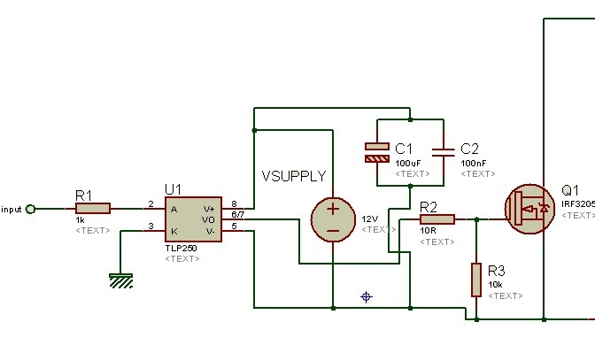

Figure 2: Photocoupler Circuitry

Component Selection

Full Bridge Rectifier

SKBPC3516 model three phase full bridge rectifier is used with features of maximum peak reverse voltage of 1600 V and 35 A maximum average output voltage, which is much sufficient for our operation. Large heatsink is used to cool this component.

Power MOSFET

IRFP460, Rds(on) is 0.27 Ω, Vds limit is 500 V, continuous drain current at 100 °C is 13 A. Switching loss increases with increasing switching. Therefore, it would be better to operate MOSFET at lower frequencies instead of 31250 kHz. Large heatsink and a fan are used to cool down this component.

TLP250 (photocoupler)

Maximum output current is 1.5 A. Supply voltage is 10-35 V, which is suitable for gate drive of MOSFET.

Freewheeling Diode

Fast Recovery Epitaxial Diode- DSEI 30, which has negative termal coefficient. This feature is useful for power circuit elements. Forward voltage is about 1.3-1.5 V under 3 A. Maximum reverse voltage is 600V and maximum forward current is 37 A, which is suitable for our operation. Small heatsink is used to cool this component.

DC Link Capacitor

Hitano’s 470 uF 450 V DC capacitor is used. For DC link voltage, 300 V is set as maximum and 150 V is left for safe operation.

Buck Converter Inductor

2.5 mH inductor’s saturation current is experimentally tested. It can work under 2 A, which is suitable for no load operation of motor.

Buck Converter Capacitor

Kendeil’s 680uF 400 V DC capacitor is used. For buck converter output voltage, 220 V is set as maximum and 180 V is left for safe operation.

Computer Simulation

## R-LOAD SIMULATION RESULTS

## 

Figure 3. The circuit of AC to DC Motor Driver with R Load

THD is equal to %204.

The output voltage and rectifier voltage of system different with duty cycles are shown as follows;

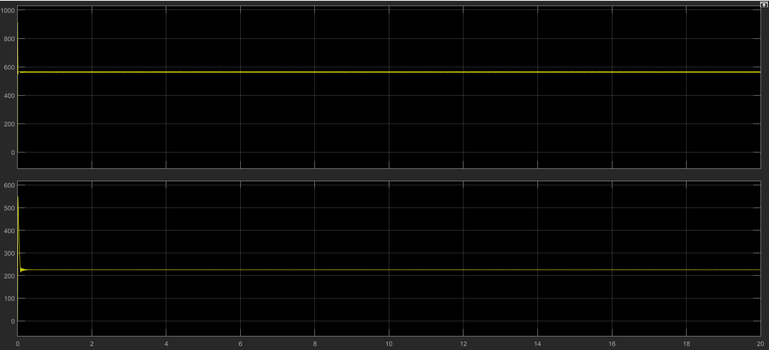

Figure 4.Output Voltage and Rectifier Voltages of R Load at %40 Duty Cycle

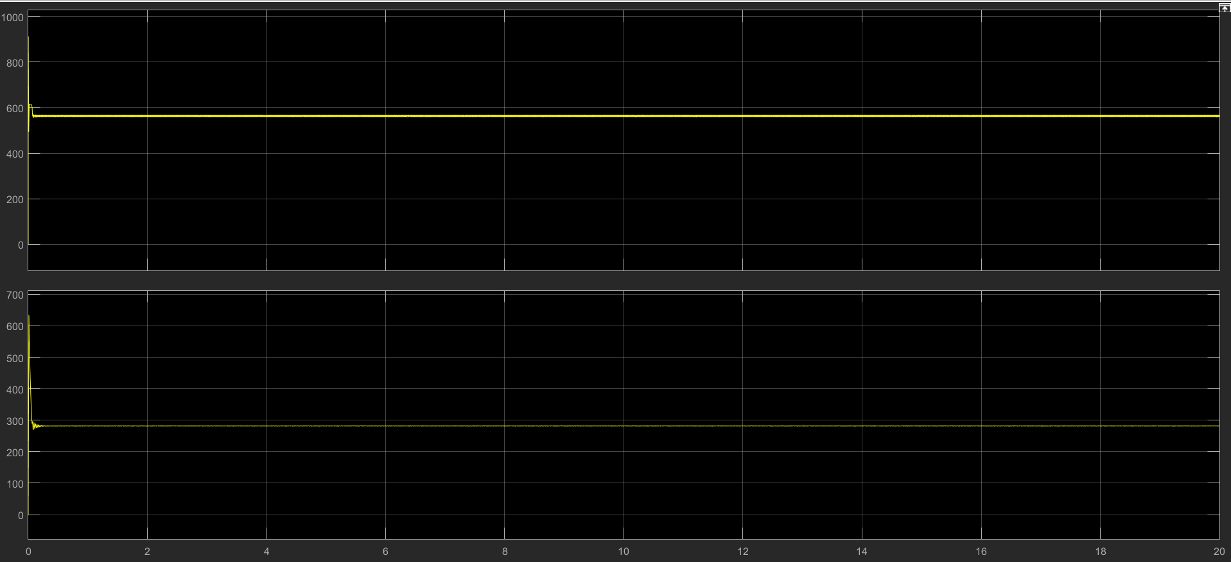

Figure 5.Output Voltage and Rectifier Voltages of R Load at %50 Duty Cycle

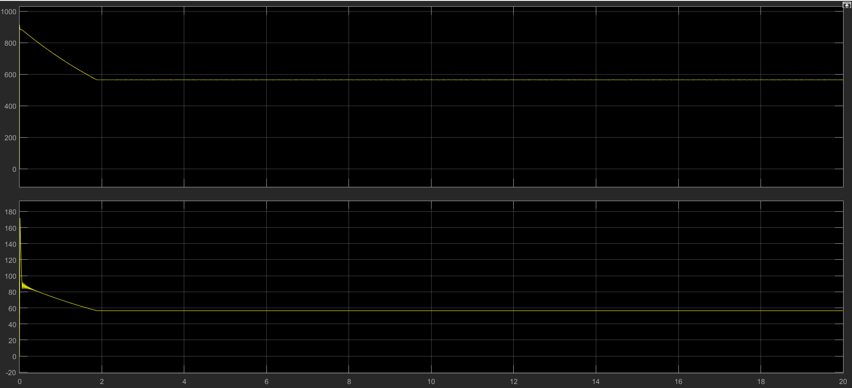

Figure 6.Output Voltage and Rectifier Voltages of R Load at %10 Duty Cycle

As expected, rectifier voltage is proportional to the duty cycle.



Figure 7: Schematic of the Drive Circuit



Figure 8: Speed of the DC Motor,Rectifier and Buck Converter Output Voltage, Armature Current Waveforms for D=0.9



THD=187%, 93.9 W*3



Figure 9: Speed of the DC Motor,Rectifier and Buck Converter Output Voltage, Armature Current Waveforms for D=0.5



Figure 3: Input Current and Voltage

THD of input current is 230,P=52.6*3



Figure 10: Speed of the DC Motor, Rectifier and Buck Converter Output Voltage, Armature Current Waveforms for D=0.1



THD=370.4%,power=10.64*3

As seen from Figure 4,5 and 6; rectifier output voltage decreases with decreasing duty cycle of gate drive, and motor speed decreases with decreasing duty cycle. Very small oscillation with frequency of 300 Hz can be seen on waveforms which cannot be filtered by DC-link capacitor and low pass filter of buck converter.

# TESTS RESULTS

In order to run the TLP 250 and cooling fan, 12 V DC source is used in setups.

## COMPONENT TESTS

Measurement of inductance;

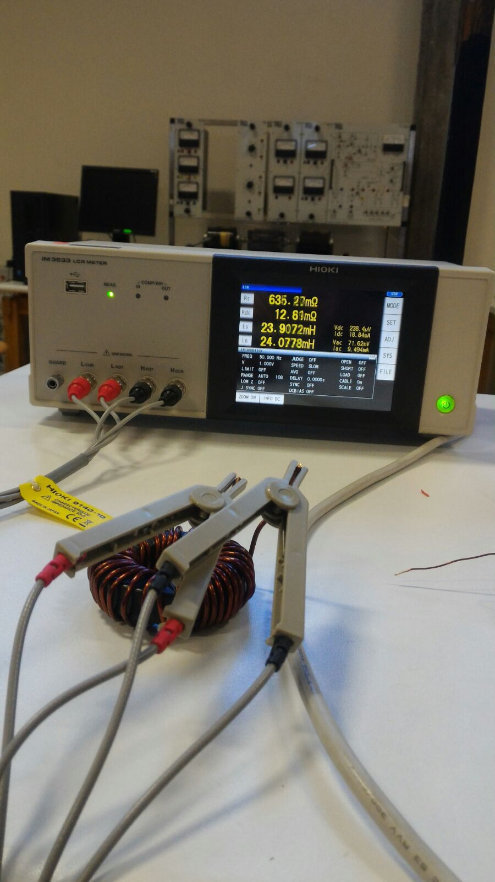

Figure 11.Inductance of Component Planned to Use in Buck Converter

Saturation of inductor;

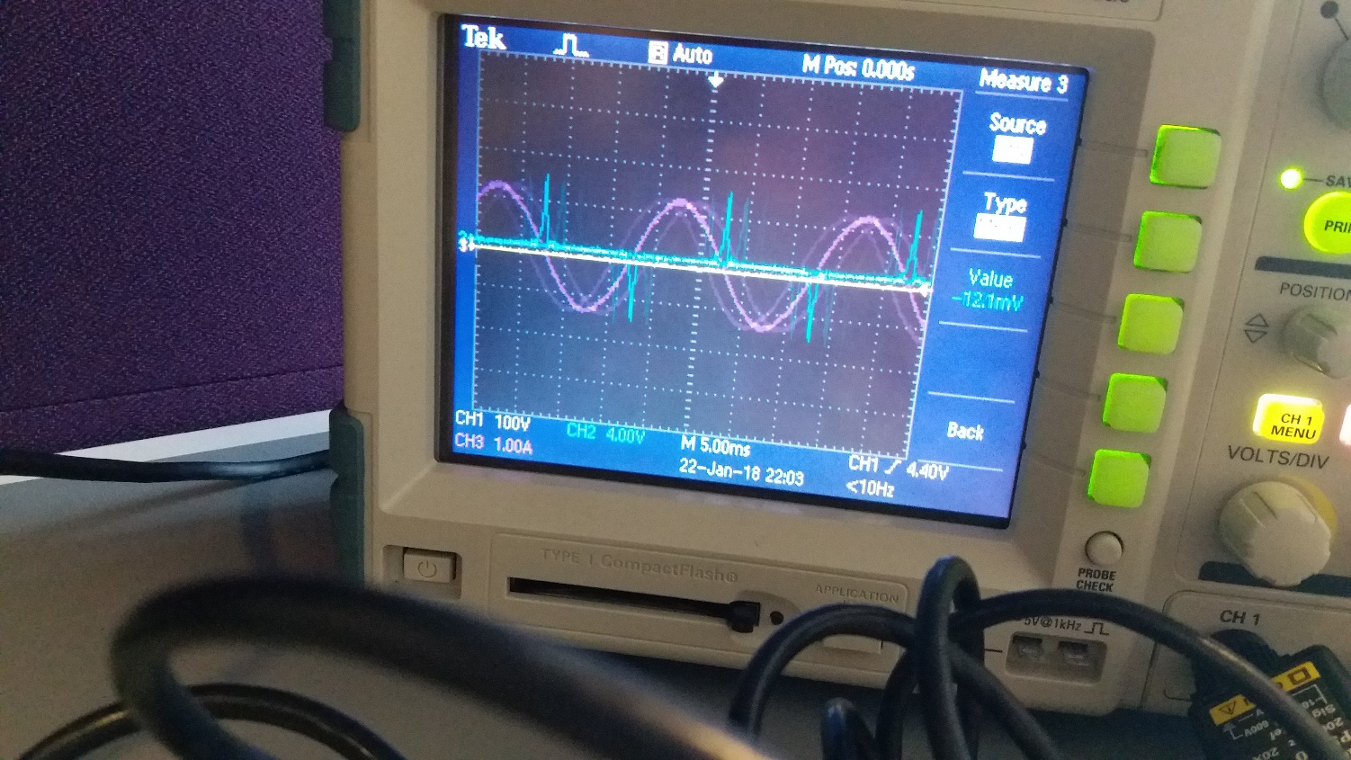

Figure 4.Saturation of Inductor Experimental Result

The inductor in Figure X is in the saturation, whose voltage (CH2) –current(CH3) graph can be seen in Figure X+1. Therefore, winding turn of inductor is reduced and inductor with 2.5 mH inductance is used in circuit.

## TLP250 Tests (Duty Cycle and PWM)

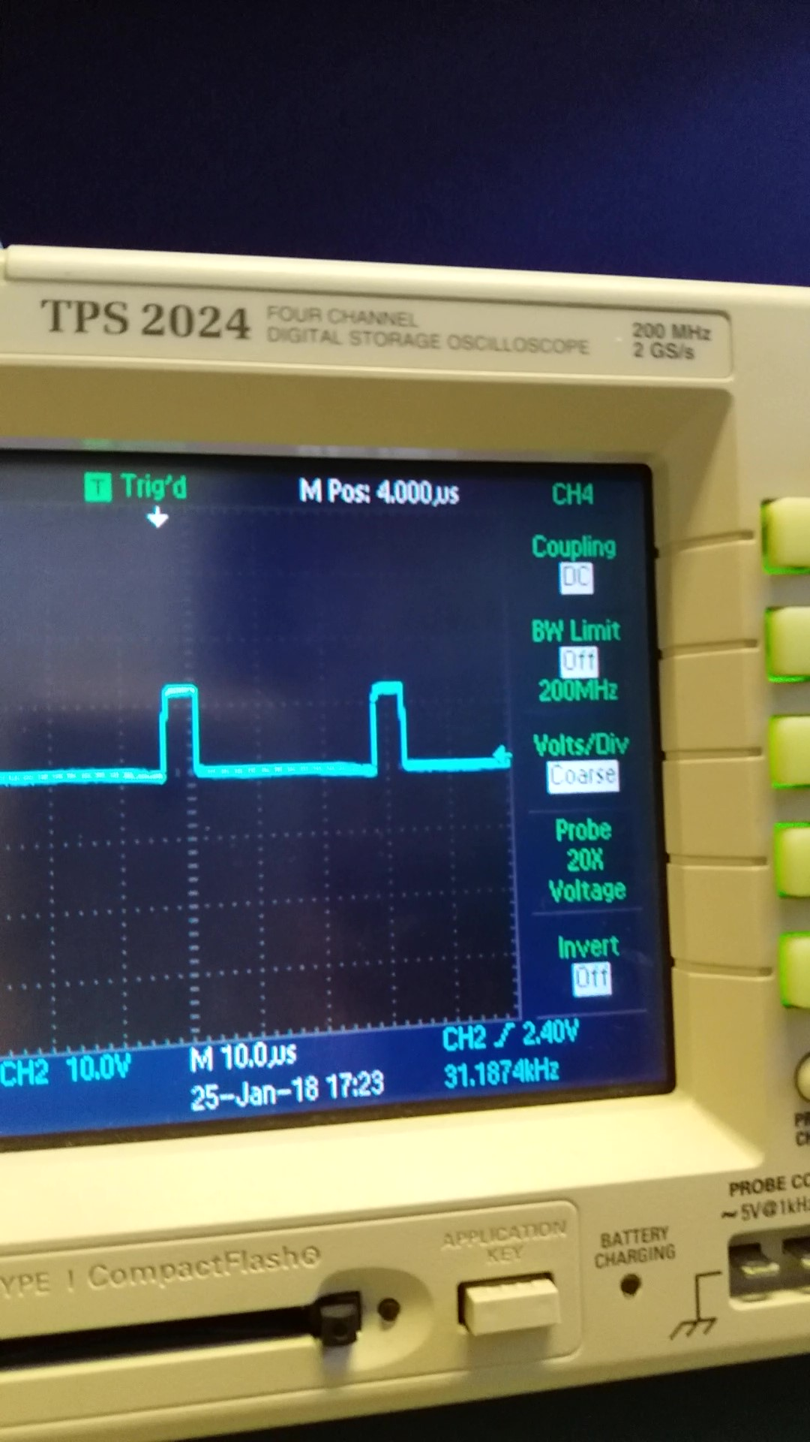

Figure 5.Output of TLP250 Duty Cycle at %15

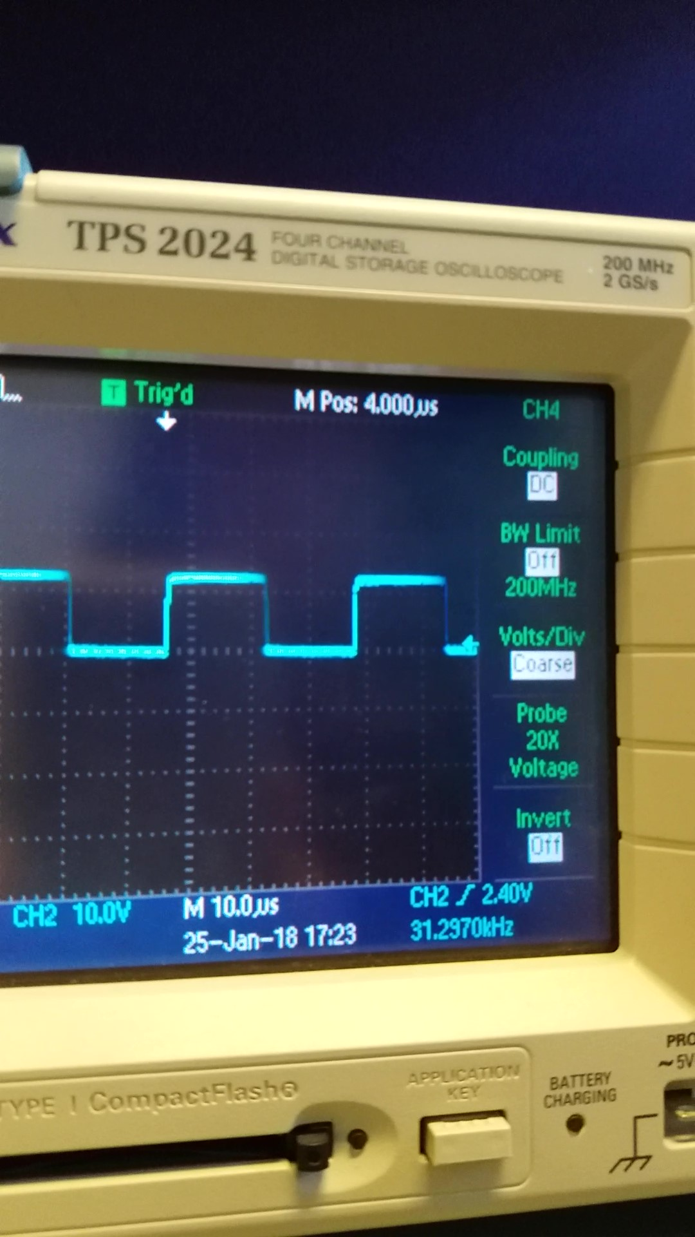

Figure 6.Output Waveform of TLP250 Duty Cycle at %50

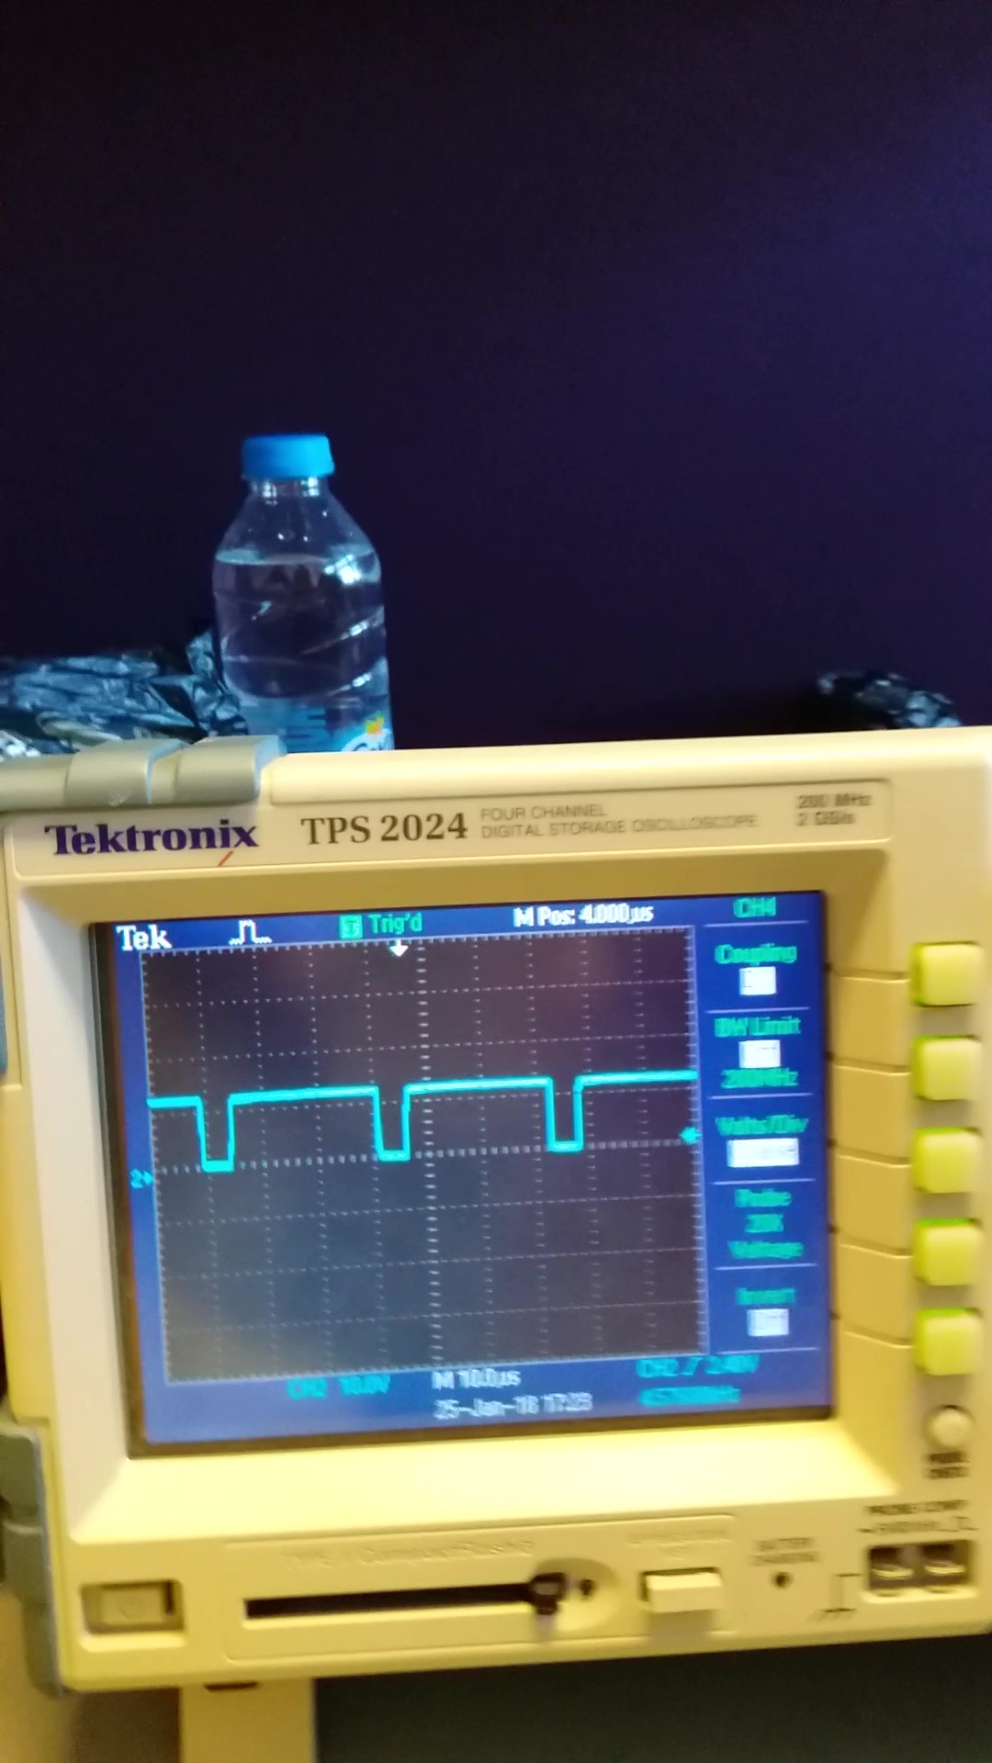

Figure 7.Output Waveform of TLP250 Duty Cycle at %90

TLP250 is tested under resistive load. As duty cycle of PWM coming from Arduino is increased, duty cycle of TLP250 increases.

## R Load Tests

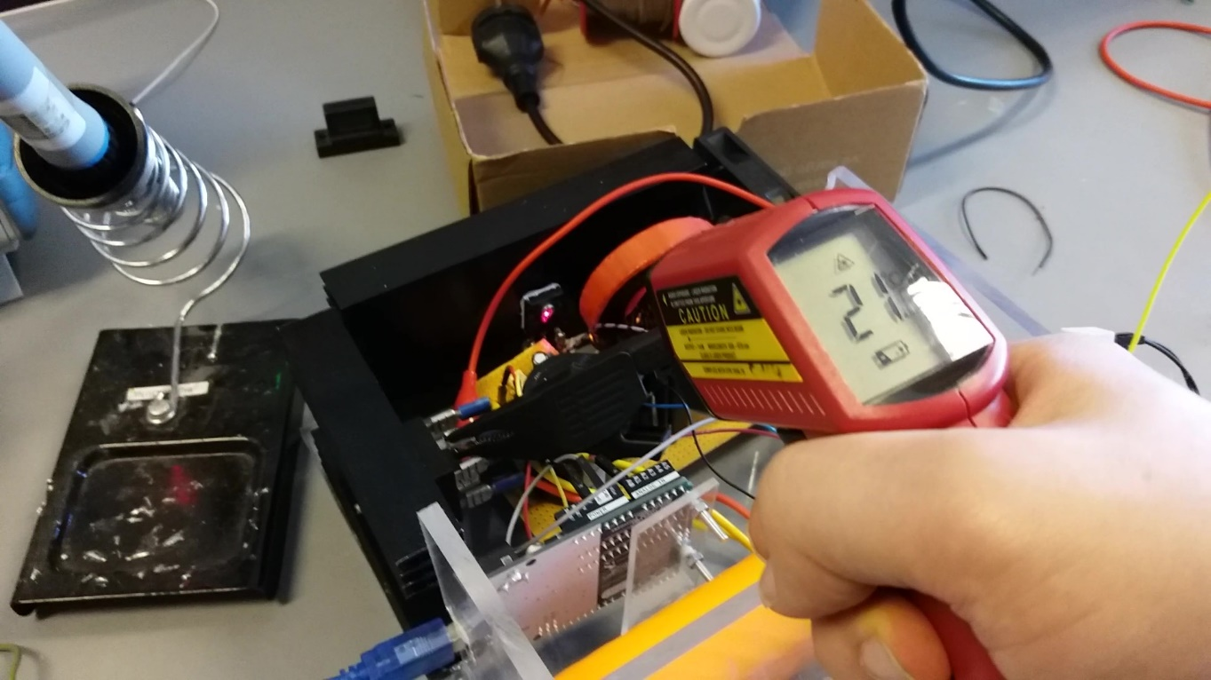

Figure 8.Temperature of MOSFET after 5 Minutes

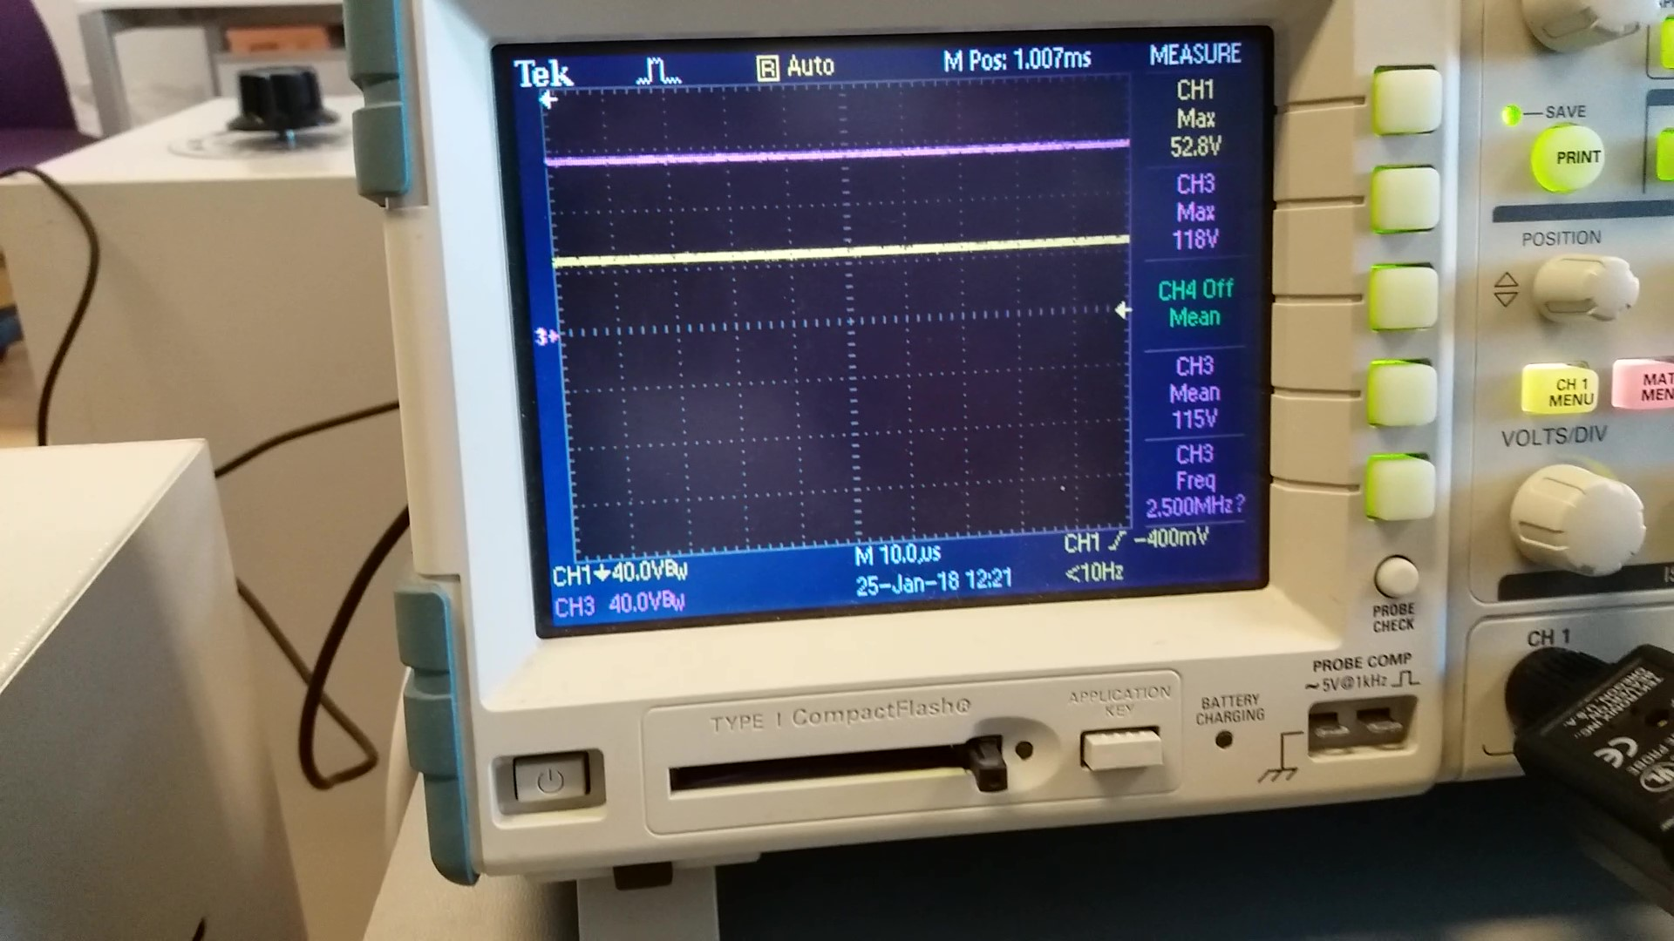

Figure 9. R-load Output Voltage(CH1) and Rectifier Output Voltage(CH3) at %30 Duty Cycle

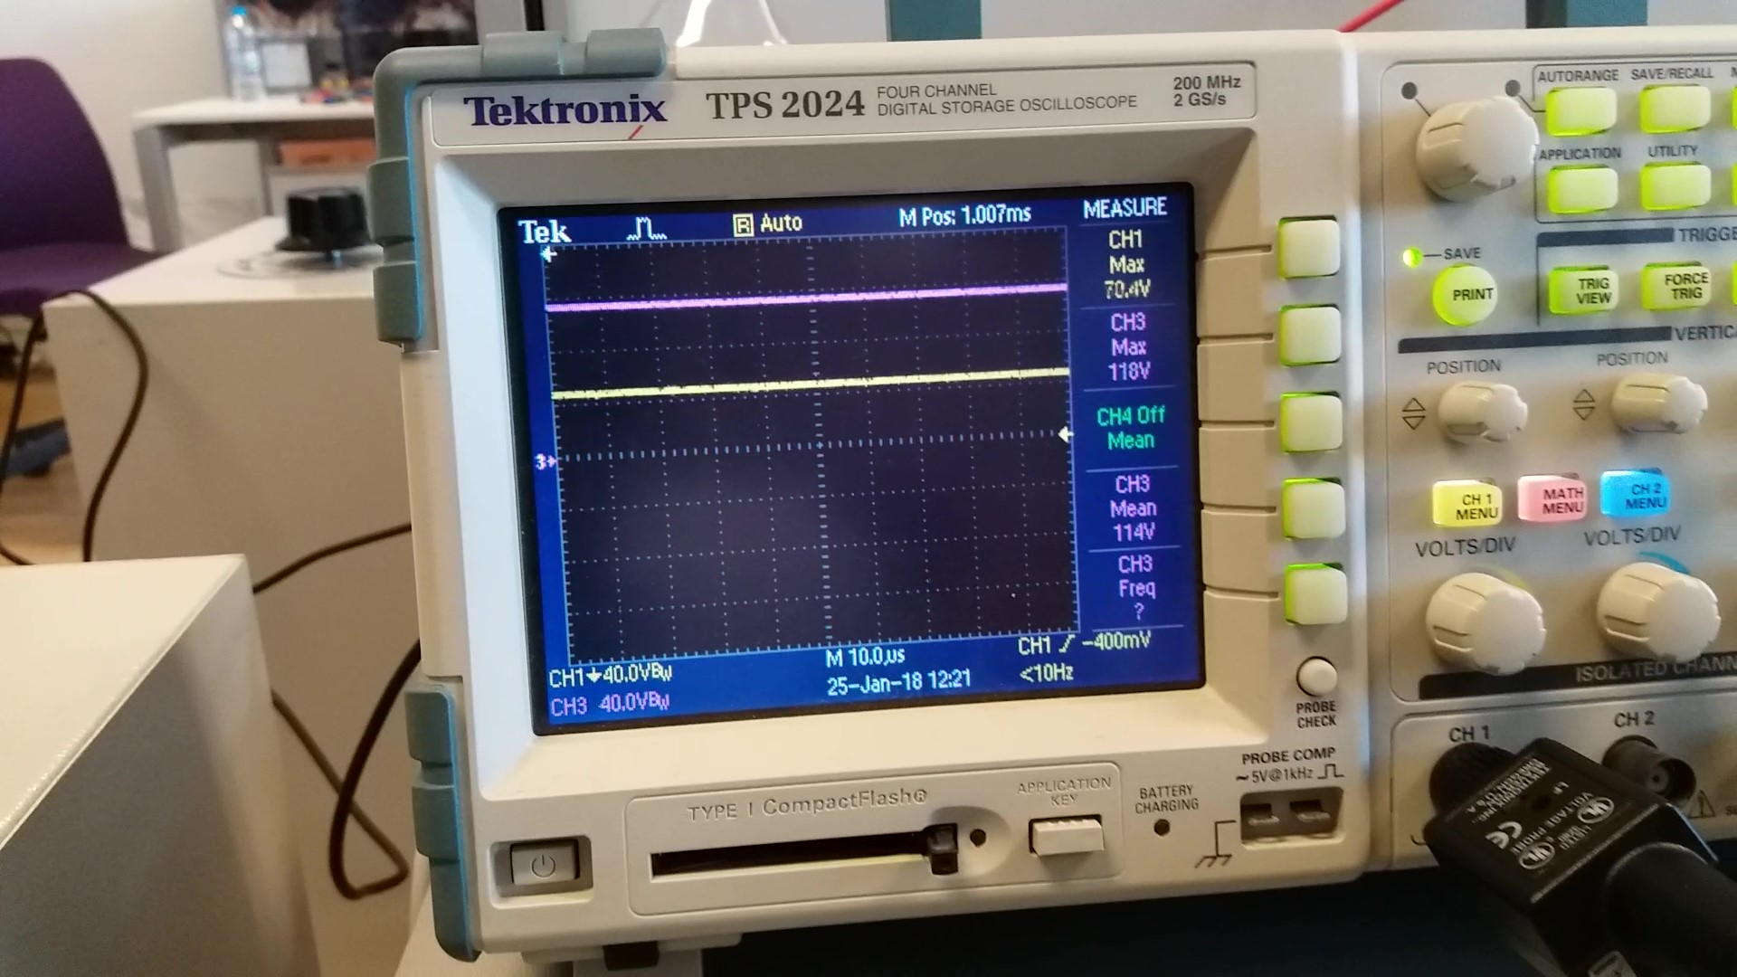

Figure 10 R-load Output Voltage(CH1) and Rectifier Output Voltage(CH3) at %60 Duty Cycle

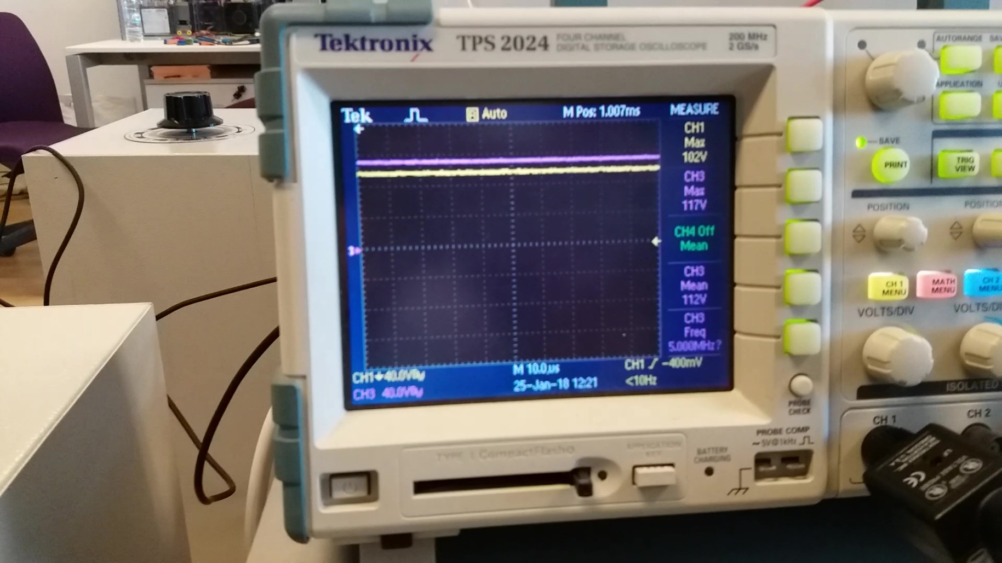

Figure 11 R-load Output Voltage(CH1) and Rectifier Output Voltage(CH3) at %90 Duty Cycle

Similar to the simulation results, buck converter voltage is increasing with increasing duty cycle of gate drive voltage.

## Motor Tests

## 

Figure 12 Temperature of MOSFET after 5 minutes (Motor at 220 V, with armature current of 1.6 A)

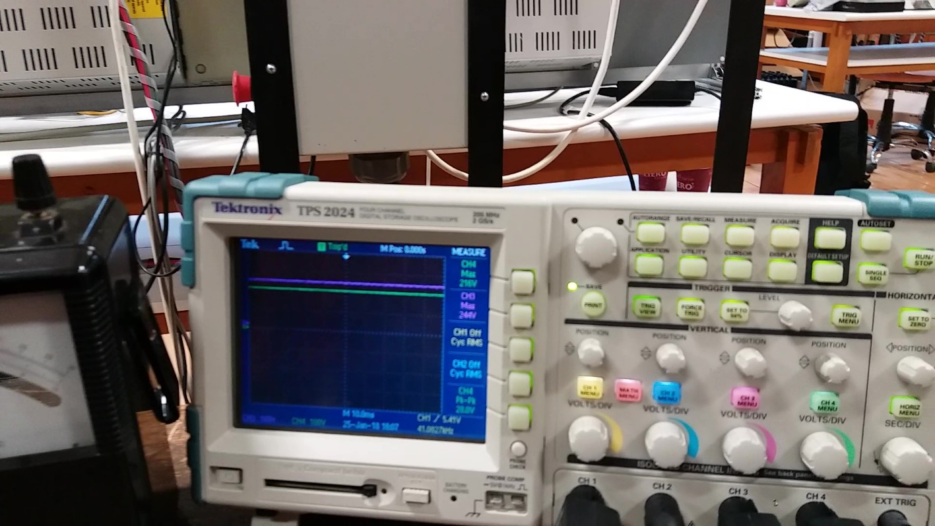

Figure 13 Output Voltage and Rectifier Output Voltage at %90 Duty Cycle

## 

Figure 14 Output Voltage and Rectifier Output Voltage at %60 Duty Cycle

## 

Figure 15 Output Voltage and Rectifier Output Voltage at %30 Duty Cycle

Terminal voltage of motor increases with increasing duty cycle.

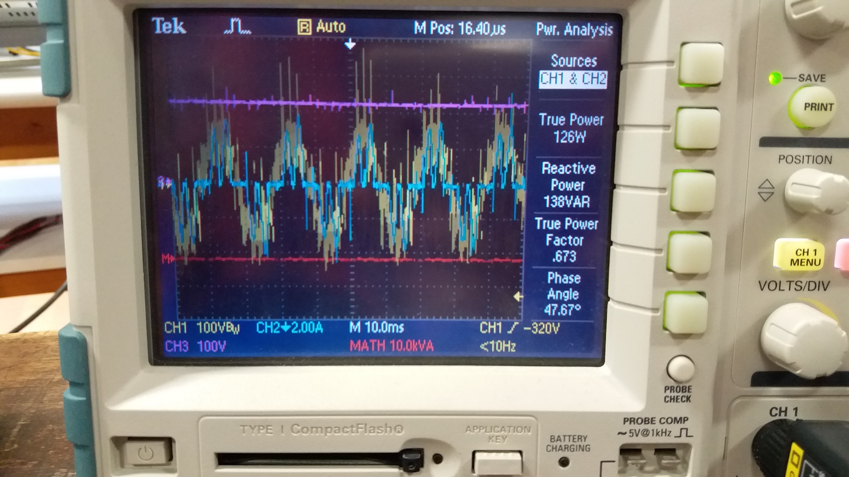

Figure 16 Input Power of System

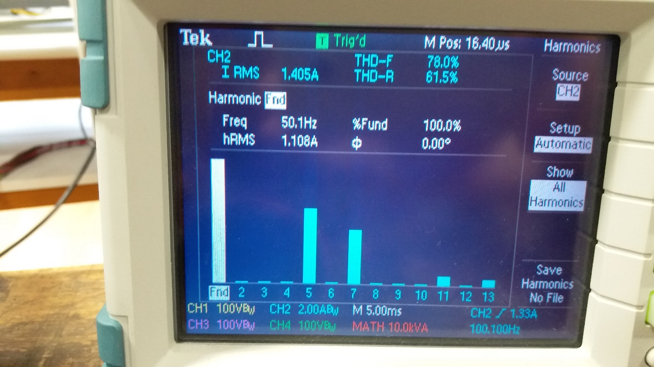

Figure 17 THD of Input Current

True power is 126 W for each phase and total true power is 126*3=378 W(Figure Y) at no load condition and Vt=220 V. Armature current is equal to about 1.6 A(Figure Y+1). Then, Output power is equal to 1.6*220 = 352 W. Power loss is 378-352=26 W. To remove this heat loss, proper heatsinks and fan combination is used. Efficiency is (352/378)*100= 93.12%

THD of line current is 78%, which is due to high capacitance of DC link capacitor, it distorts the input current. However, measured THD is not as high as in simulations because of line inductance in real.

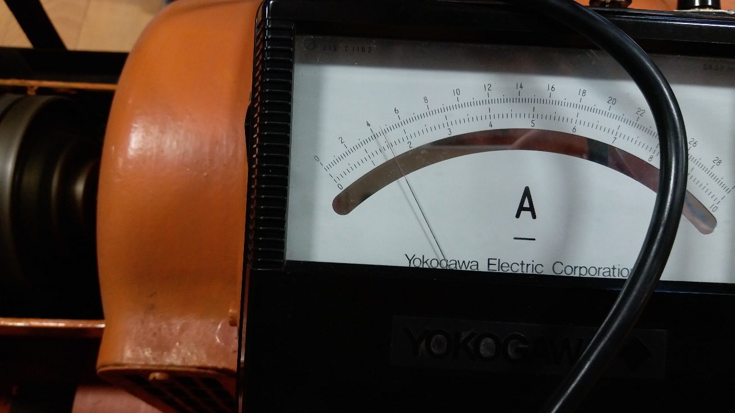

Figure 18 Output Current of System (Armature Current) When Output Voltage (Terminal Voltage) is 220V

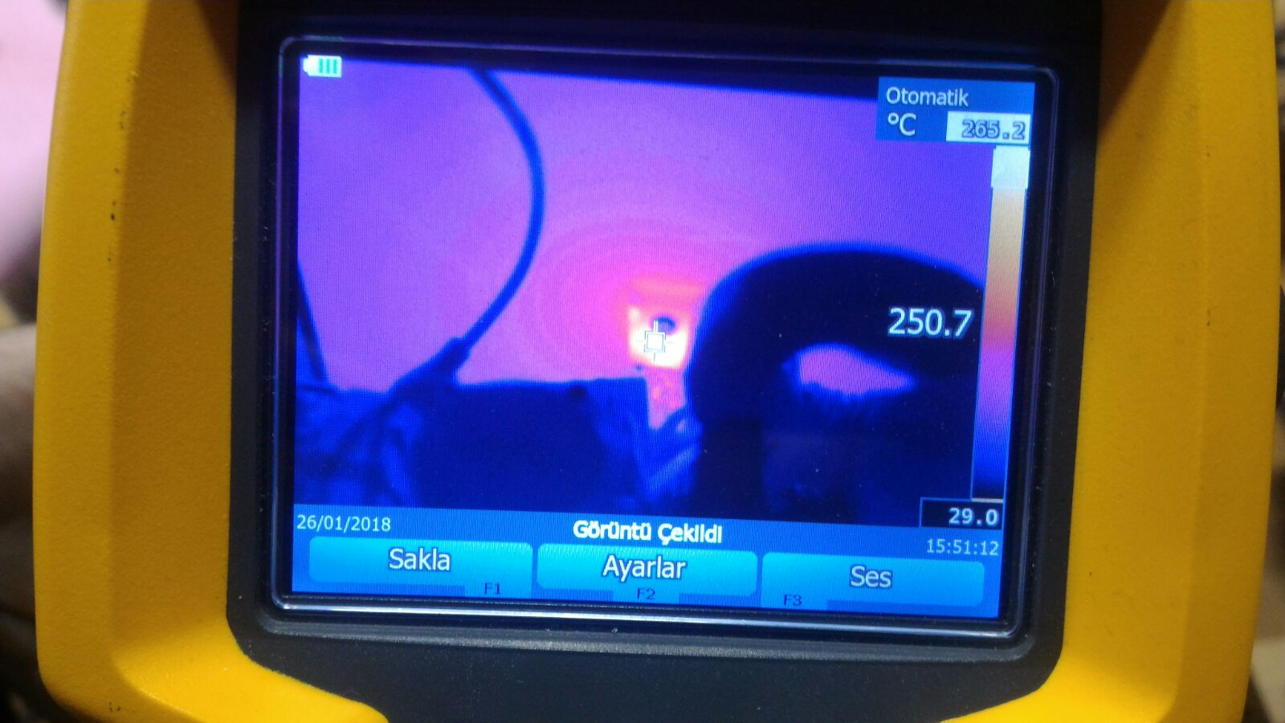

Figure 19 Temperature of MOSFET after 30 Seconds of Full Load Operation (12.7 A armature current)

At demonstration, robust design bonus is tried and failed. The failed MOSFET is seen at the Figure Y+2 at 250 °C.

# Conclusion

In this hardware project, we observed AC to DC motor drive with different speeds. The speed is adjusted according to DC output of our setup. We observed simulation results and experimental results are similar but not same. Also, we learned that using material is very important for hardware project. Moreover, we learned that we do not thrust sellers specially in Konya Street. We should search correct component for our system otherwise we can encounter some problems such as shorting or burning our components. In addition, we could not observe any problem as theoretically or on simulation works. However, we can encounter some problems as practically. Therefore, we have to test our setup again and again for taking better results. Also, we observed switching loss is big problem for our system. Since, switching loss cause to increase temperature of our components. Therefore, we have to control that frequency is not vey high such as higher than 30 kHz. In addition, we observed parasitic effect on our setup. The cable can affect the system as capacitive or inductive because of length of cable. Parasitic effect cause to some peak of our voltage and current. This condition can damage our setup. For overcome this problem, we should select our cable’s lengths and features carefully. In addition, We got idea about making AC to DC motor drive as hardware. Making this setup is very difficult and it takes very long time. To conclude, we think that the project is very beneficial for us. Thanks to our instructor for this project.